NEPAL COLLEGE OF INFORMATION TECHNOLOGY
Balkumari, Lalitpur
Affiliated to Pokhara University

LAB REPORT FOR DATABASE MANAGEMENT SYSTEM


LAB REPORT 2: FAMILIARIZATION WITH DDL COMMANDS

Submitted by: Submitted to:
Name: Arpan Adhikari Er. Simanta Kasaju
Roll No.: 231309
BE-CE (3rd SEM)

S. N | LAB TOPIC | DATE | REMARKS
1. | INTRODUCTION TO SQL | 10th Nov
2. | FAMILIARIZATION WITH DDL COMMAND | 17th Nov

LAB 2: FAMLIARIZATION WITH DDL COMMANDS

OBJECTIVE:
The objective of this lab is to help students become proficient with Data Definition Language (DDL) commands in SQL, which are essential for defining and modifying database structures. Students will learn to use DDL commands, such as CREATE, ALTER, and DROP, to effectively create and manage tables and databases. This lab emphasizes understanding the role of DDL in structuring databases within a relational Database Management System (DBMS).

THEORY:

Data Definition Language (DDL) is a fundamental part of SQL, used to define, modify, and manage the structure of database objects in a relational Database Management System (DBMS). While Data Manipulation Language (DML) is primarily focused on data itself—such as inserting, updating, and deleting rows—DDL is concerned with the setup, layout, and modification of the database structure. DDL commands are essential to the creation, organization, and management of data storage, enabling users to configure a database for optimal storage, retrieval, and integrity of data.

Key DDL Commands:

1. CREATE: The CREATE command is foundational in database structuring. It allows users to establish new database objects, such as databases, tables, views, indexes, and schemas. When creating a table, for instance, users specify the columns, data types, constraints, and other characteristics that define the data format for each entry. Creating a table or database involves determining how the data will be organized and structured, including choosing the types of data (e.g., INTEGER, VARCHAR, DATE) and applying constraints (e.g., PRIMARY KEY, NOT NULL, UNIQUE) to enforce data integrity.

2. ALTER: The ALTER command allows users to modify an existing database structure without deleting it. This includes operations like adding, deleting, or renaming columns in a table, or changing data types and constraints of existing columns. ALTER is particularly useful for adapting databases as needs evolve, such as when a new requirement calls for additional data fields, or when a constraint is needed to ensure data accuracy. ALTER also allows database administrators to adjust the schema without losing data, making it an essential tool for database maintenance and evolution.

3. DROP: The DROP command removes entire database objects (like tables, views, or indexes) from the database, including all associated data. When a table or database is no longer needed, or if a significant restructuring requires its removal, the DROP command is used to delete it. DROP is a powerful command and should be used cautiously, as it is irreversible and can result in complete data loss for the deleted objects. Therefore, it is important to ensure backups or to thoroughly verify requirements before using DROP.

4. TRUNCATE: TRUNCATE is a command that removes all rows from a table without affecting the table’s structure or other database objects like indexes and constraints. Unlike DELETE, which logs each row deletion individually, TRUNCATE performs a bulk removal, often faster and less resource-intensive. TRUNCATE is especially useful when needing to clear data from a table quickly, while still preserving the table structure for future data insertion.

Importance of DDL in Database Management:

DDL commands form the backbone of any relational database's structure, defining not only how data is stored but also how it can be managed, validated, and accessed. Proper use of DDL commands allows for the following benefits:

- Data Integrity and Consistency: With constraints applied through DDL (such as PRIMARY KEY, FOREIGN KEY, UNIQUE, and CHECK), the database can enforce rules that maintain data quality and logical relationships between tables. For example, setting a PRIMARY KEY ensures each record has a unique identifier, while FOREIGN KEY constraints establish valid connections between related tables.

- Flexibility and Scalability: ALTER commands provide flexibility, allowing database structures to evolve as requirements change. This adaptability is crucial for growing databases where additional fields, indexes, or constraints may become necessary to support new features or optimizations.

- Efficient Data Management: DDL enables database administrators to configure efficient storage structures, such as indexes for faster data retrieval and views for simplified access to complex queries. With these structures in place, data can be accessed and manipulated more efficiently, improving the overall performance of applications that rely on the database.

Common Data Types and Constraints in DDL:

Data Types: DDL commands define the data types for each column, ensuring that data is stored in a consistent format. Common data types include:
- Numeric: INTEGER, DECIMAL, FLOAT for storing various forms of numeric values.
- Character: CHAR, VARCHAR for storing text of fixed or variable length.
- Date and Time: DATE, TIME, and TIMESTAMP for handling temporal data.
- Boolean: BOOLEAN for storing true/false values.

Constraints: Constraints enforce rules on data to uphold integrity and relevance:
- PRIMARY KEY: Uniquely identifies each row in a table.
- FOREIGN KEY: Enforces a relationship between tables, ensuring that data in one table corresponds to valid data in another.
- NOT NULL: Ensures that a column cannot have a NULL value, requiring data entry for each row.
- UNIQUE: Enforces that all values in a column are unique across rows.
- CHECK: Allows a condition to be specified, restricting the values that can be stored in a column.

Steps for Executing DDL Commands:

1. Setup of Environment: Install and configure a DBMS, such as MySQL, PostgreSQL, or Oracle, often using tools like XAMPP for local database management.
2. Database Creation: Use the CREATE DATABASE command to establish a new database, which serves as the container for tables and other objects.
3. Table Creation and Structuring: Define tables within the database using CREATE TABLE statements, setting columns, data types, and constraints.
4. Modification and Adaptation: Apply ALTER commands to add or remove columns, change data types, or apply new constraints as requirements evolve.
5. Data Removal and Structure Maintenance: Use DROP and TRUNCATE as needed to remove unneeded objects or clear data while preserving structures.

Understanding and utilizing DDL commands is crucial for efficient database administration, as it provides the foundation for a reliable, well-structured, and scalable database environment.

Questions:
Question No.1:

- Create database lab2.
- Create table shop.

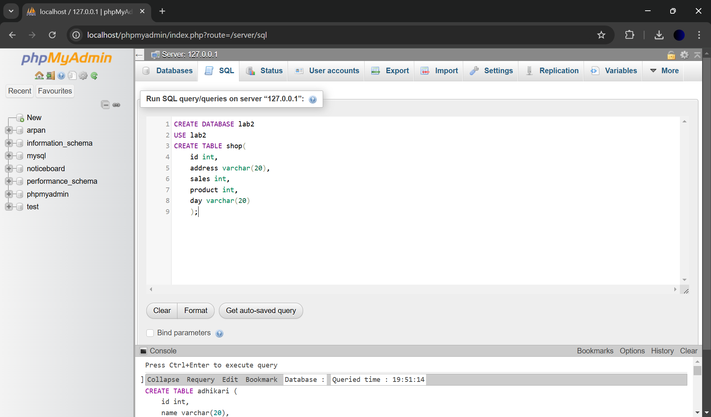

- Insert Records in the table.
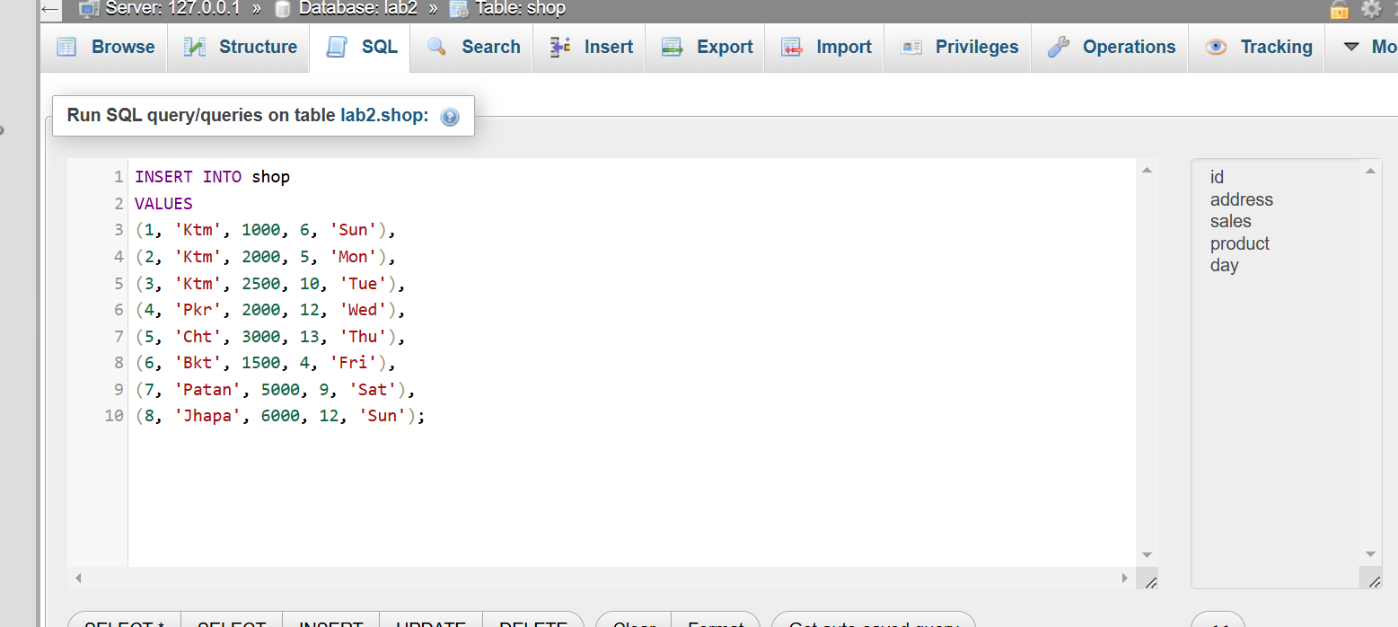
- Add new column profit to shop table and drop that column.
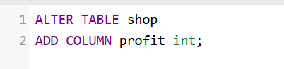

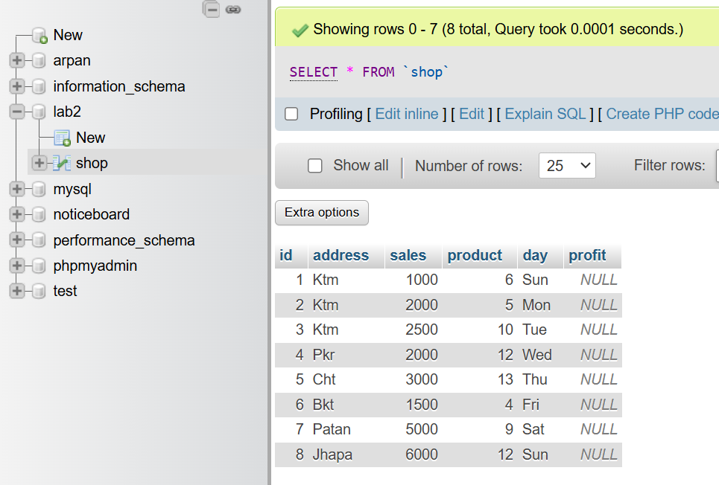

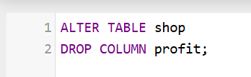

- Alter data type of day to char.

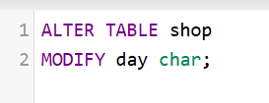
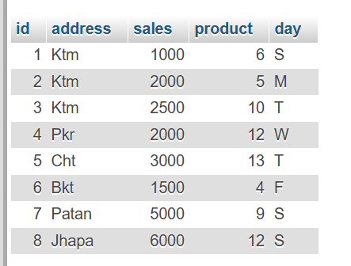

- Rename table name shop to pasal.

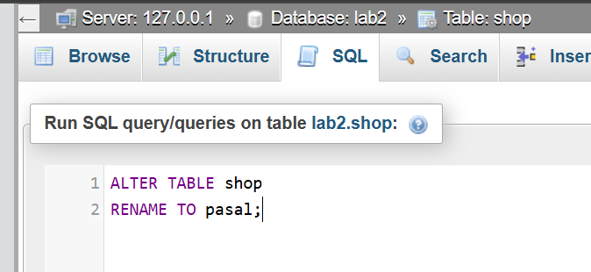

- Rename id as shop_id.
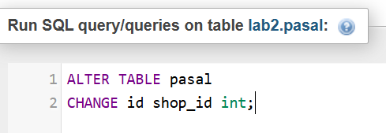

- Add new column country instead of NULL value provide country by default.
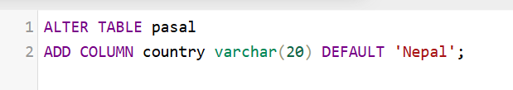

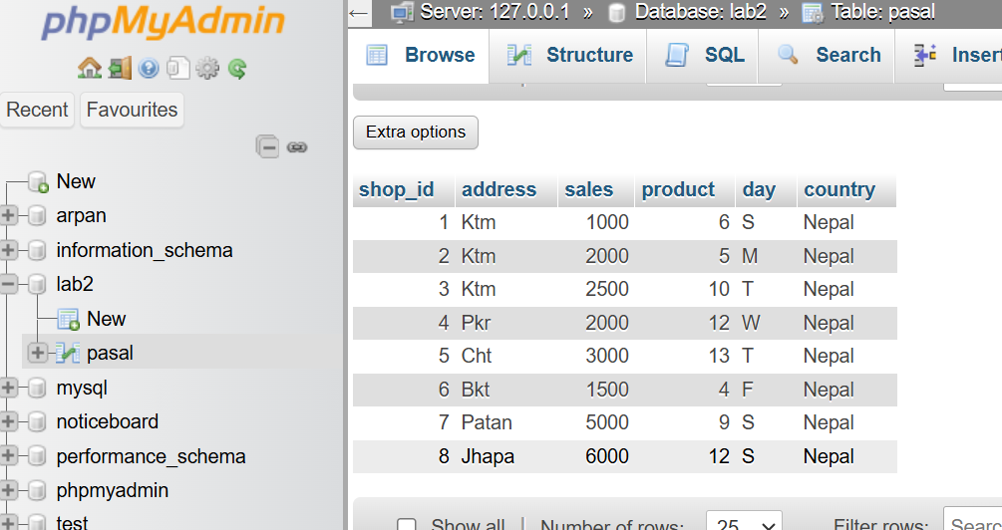

- Create table shoppy with same column name.
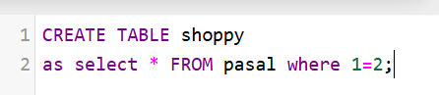

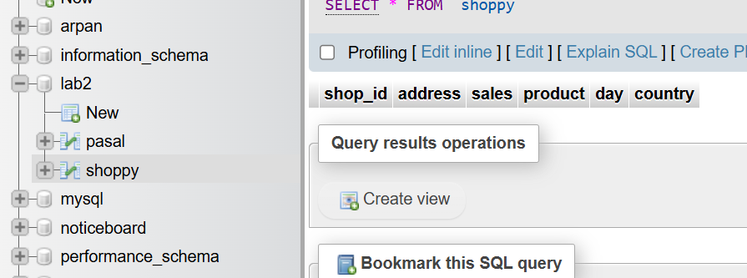

- Create table shop with same column and records as well.
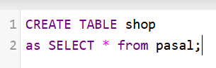
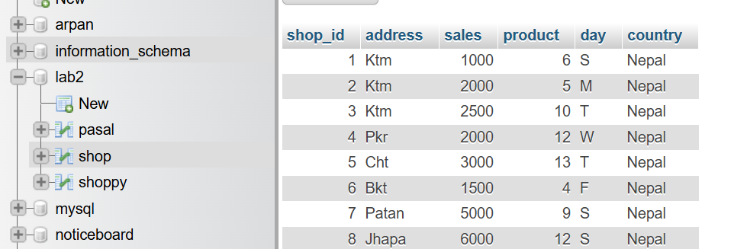

- Truncate table shop.


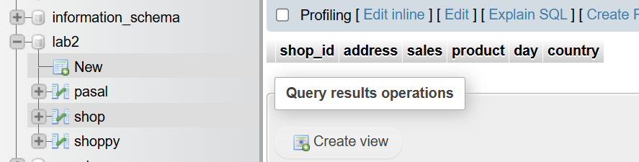

- Drop Table shop
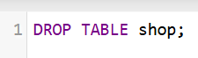

- Drop Database lab_2
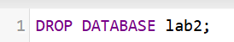

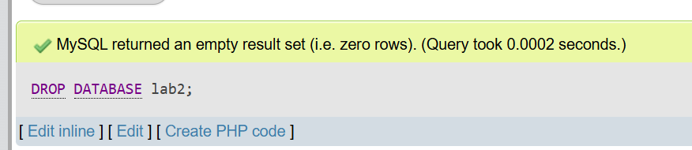

Question No.2 :

- Use the same database lab2.
- Create table student.
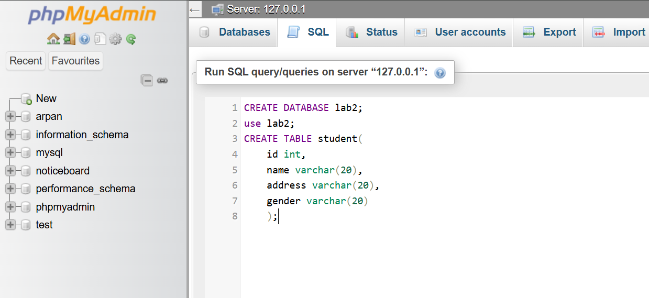

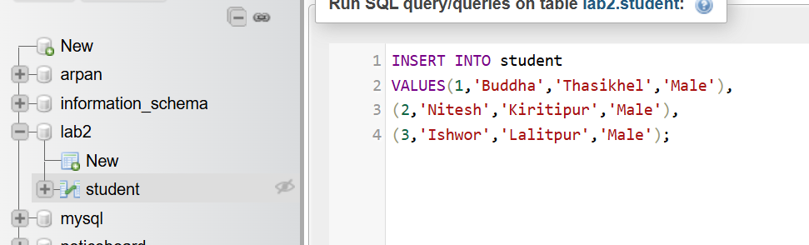

- Add new column phn_no and marks.
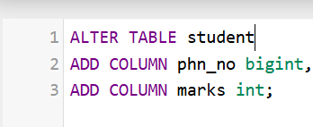

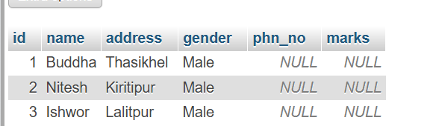

- Add column country which default value is Nepal and drop phn_no and marks.
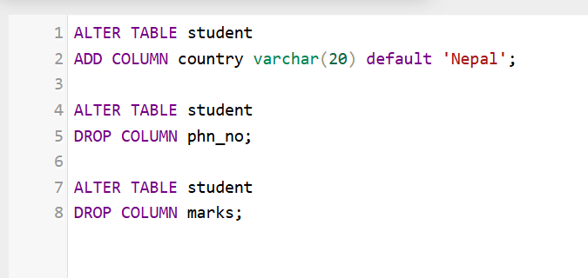

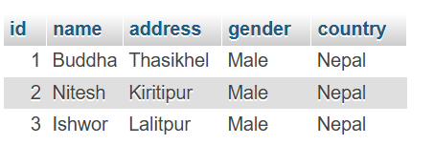

- Rename student table to students.
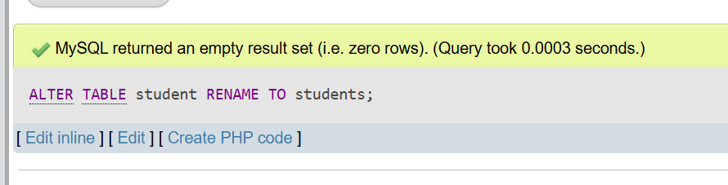

- Rename id to s_id and name to student_name.
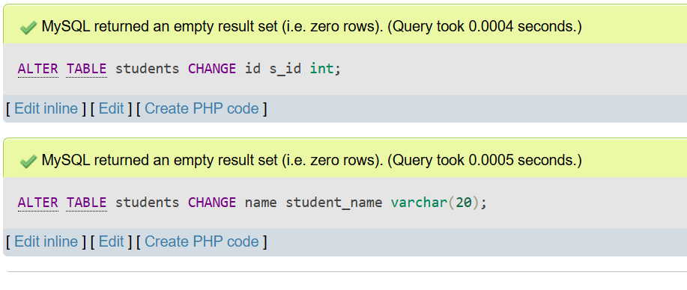

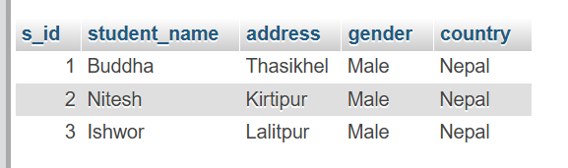

- Drop Column gender.
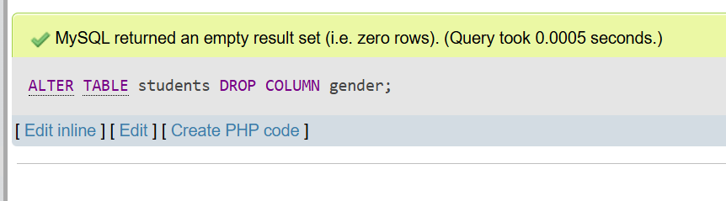

- Truncate above table.
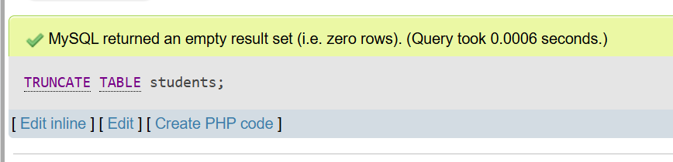

- Drop table and database.

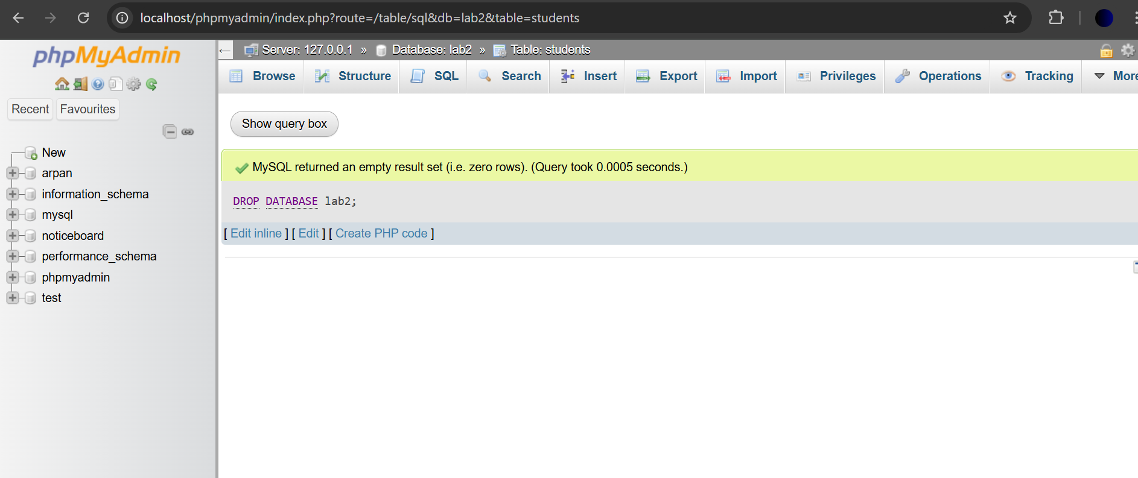

CONCLUSION:

In this practical, I gained a deeper understanding of Data Definition Language (DDL) commands and their role in managing the structure of relational databases. By working with commands such as CREATE, ALTER, DROP, and TRUNCATE, I learned how to define, modify, and remove database objects like tables and indexes. The practical application of these commands helped reinforce the importance of organizing and structuring data effectively, ensuring its integrity, scalability, and efficient management. This experience provided a strong foundation in database design and administration, which will be essential for handling complex database systems in future projects.

